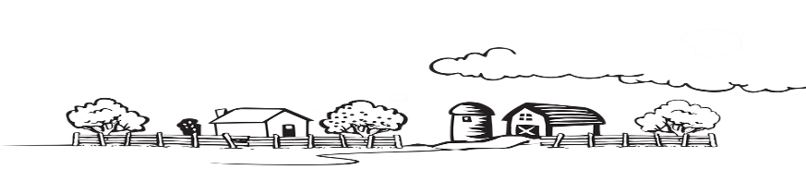
PRINCIPLES OF AGRICULTURE
COURSE SYLLABUS
Mrs. Rosario
rosariod@hudsonisd.org

DESCRIPTION
This course in an introduction to Agriculture, with an emphasis on learning about the FFA organization. It is designed as an exploratory class, to investigate the many different sectors of the Agriculture industry. This class is also a prerequisite for other Ag classes that you may be interested in taking in the future, including welding, construction, animal management, horticulture, wildlife management, and others.

COURSE TOPICS
- Introduction and explanation of the science of Agriculture
- Explanation of the Angelina County Youth Fair opportunities
- Careers in Agriculture
- The FFA Organization
- Introduction to Animal Science and Management
- Introduction to Soils and Horticulture
- Introduction to Ag Construction

REQUIRED SUPPLIES
- Composition Notebook
- Pen and Pencil
- Box of Kleenex

GRADING
- Daily work
- Participation in activities (which may require getting dirty!)
- Projects
- Exams
- Mid-Semester and Final Exams

*Each student in Principles of Ag is required to memorize and recite the FFA Creed to the rest of the class. This will count as 5 daily grades and one test grade. Maximum grade if read, not recited, is 70.

